PODCAST CREATOR SIGNABLE FORM  Air It Out with Pac Man | Creator Agreement | 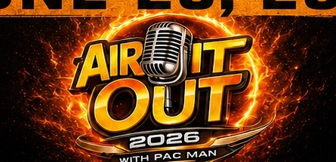
Instructions: Fill in your information, read the agreement summary, sign at the end, then send the completed form back by email or text. A typed name on the signature line may be used to confirm your agreement when you return the completed form.
Creator legal name |  | Podcast name
Phone number |  | Email address
Agreement date |  | Podcast social/handle, if any
Agreement Summary
• Full creative control: You control your podcast name, topics, guests, tone, style, format, opinions, and creative direction.
• Posting freedom: You may post, share, and promote your podcast content as you please, as long as it follows this agreement.
• Podcast name rule: Anything released on the Air It Out with Pac Man YouTube channel must be clearly posted under your podcast name only.
• Copyright rule: Do not submit, upload, or request the use of anything that could get the Air It Out with Pac Man YouTube channel copyright claimed, struck, restricted, or taken down.
• No uncleared material: Do not use copyrighted songs, beats, movie clips, TV clips, sports clips, YouTube clips, photos, graphics, or artwork unless you own it or have permission to use it.
• Responsibility: You are responsible for your guests, statements, materials, outside clips, music, images, and creative choices.
• Channel protection: Air It Out with Pac Man may refuse, delay, private, remove, or edit content if it puts the channel at risk of a copyright strike, platform strike, legal issue, privacy issue, safety issue, or channel restriction.
• Permission to host and promote: You give Air It Out with Pac Man permission to host, upload, publish, share, clip, promote, and distribute your podcast content on the Air It Out with Pac Man YouTube channel and related social media pages.
• Ownership of identity: You keep your podcast name, show concept, personal brand, and original ideas unless a separate written agreement says otherwise.
• Professional conduct: You agree to respect the platform, schedule, recording space, audience, and people involved.
• Ending the agreement: Either side may end the agreement in writing. Air It Out with Pac Man may immediately remove or private any content that puts the channel at risk.

Agreement + Signature
☐ I have read this form, understand the rules, and agree to follow them.

Creator typed/electronic signature | Date signed
Creator printed name | Phone/email used to return form
Air It Out with Pac Man representative name | Representative signature
Representative date signed

Main rule | Do not get the Air It Out with Pac Man YouTube channel copyright struck.
Note: This is a simple creator sign-off form prepared for business use. Have a qualified local attorney review it if you want a fully customized legal agreement.

